THE WITNESS
Steven Quayle spoke of an occurrence, still classified by the US Government, in his popular Radio Show “Coast to Coast”: the events allegedly happened in 2002 on a desert part of the Afghanistan, when a U.S. Army squad went missing. A Special Ops Task Force was sent to find out what had happened, and the soldiers walked along a ragged, mountainous trail until arriving at the entrance of a large cave. Pieces of broken U.S. military equipment and gear were scattered all around the clearing. The Task Force was about to enter the cave to explore its recesses when a 13-feet, red-headed, six-digit, double-toothed humanoid emerged and attacked them.

According to the witnesses, the giant pierced one of the soldiers with his long spear killing him, before the rest of the squad could take him down, shooting at his face for thirty seconds straight.
The body of the giant was packed and loaded into a helicopter, and transferred to a secret location in the USA for study.
Based on Quayle’s story L.A. Marzulli succeeded in identifying and interviewing one of the members of the Task Force who actually saw – and shot – the Giant of Kandahar, as the event became to be known.
The soldier said that his squad, on searching the cave, had come around a gigantic humanoid with a thick red beard and long hair of the same color. Inside the cave there were remains of human bones, leading the military to think that the creature was a cannibal.
One of the soldiers was impaled by the weapon the giant wielded, a kind a long spear or lance, during the 30-second shootout (it took that long to kill the creature.)
According to the witness the USG didn’t disclose the event and has no intention to do it in the future, because “giants don’t match with the way we explain our world.”

The giant weighed about 500 Kg as estimated by the C-130 Cargo plane team who transported the body from the pick-up location to the United States. The witness remembers that one of the pilots noted a “terrible stench of musk and dirt” exuding from the cadaver, like a man “who didn’t shower for 10 years.” (The witness told Marzulli that the odor was more intense than that of a skunk, and close to that of a pile of decomposing corpses.)
The giant wore a canvas or animal hide to protect his feet, like some sort of moccasins.
We searched online and retrieved the original interview. The witness talks details about the encounter with this huge being which had occurred in a remote area near Kandahar, Afghanistan. Marzulli calls the witness “The Shooter” due to his active involvement in the giant’s killing, and claims to have interviewed him three times on the phone and at different times, to check for any discrepancies in his story. Having found none, eventually he was convinced that the event was real, and decided to meet the military in person. The meeting occurred in an undisclosed location.

Coincidentally, on one of his trips to meet with “The Shooter”, Marzulli found out that his driver was a former military who had served in Afghanistan few years later the event he was investigating, and that he knew about it. This new witness, code named “Mr. D.”, was interviewed by Marzulli in the documentary series “Watchers X” and said:

“When we came back to base we would hear our colleagues talk about a unit that had found and killed a person inside or at the entrance of a cave. At first I didn’t think much of it, but then I’ve heard that that fellow’s size was three times that of a human being, and that he had more fingers and toes than a normal man; that he had red hair and that a special unit was looking for him...”
As the documentary rolls on, Marzulli shows an iron tip weighing about 6 Kg which, if attached to a pole to make a spear, would be difficult to maneuver for a middle-sized man. That tip was found in Michigan and given to an Indian chief of the reservation. But it is the same object that “The Shooter” claims to have seen in the hands of the Giant of Kandahar during the attack. The same iron tip that killed his colleague.
In the video, “The Shooter” is called “Mr. K”, and is introduced just as a worker. He confirmed that he was serving in Afghanistan in 2002, and that his unit had been called for a rescuing mission of another unit which had gone missing in a remote area of that country (so remote, he says, that they had to get there via air with a 4Km distance flight.)
“Mr. K” ‘s unit is deployed on a crest of a plateau which was marked as one of the check points where the missing unit should have reported his position.
Since they left the base, the soldiers were wondering what could have happened to that unit. They thought of an ambush, but that sounded weird because even in that case there is always time to send a message to the base. In this case no stressed call had arrived, no signal had been sent.

So this rescue unit is on the ground searching for tracks and, while descending a slope they see a trail. They follow it. After a curve they see the large entrance of a cave surrounded by rocks, which is another “weird thing” according to “Mr. K” (he doesn't’ elaborate on that, though.)
Several cracked bones are found among the rocks around, but no identification from their observation point was possible. However, together with the bones, shattered pieces of radio communication devices, U.S. Military equipment, were clearly visible. The unit’s first thought was again for the ambush hypothesis, or the attack of a wild animal. It could be anything at that point.
The entrance of the cave had a clearing large enough to host the unit; however the soldiers were standing at a lower level, and a vertical wall of rock separated them from the clearing.
The soldiers distanced themselves, assuming the anti-ambush stance, when something leaped out of the cave at a speed that caught the Task Force by surprise. It was a human being at least 12, most likely 13 feet tall:

“It was a monster,” says “Mr. K,” “Red beard, scarlet red long hair covering his shoulders, and Dan [one of the soldiers] runs toward him firing his weapon, and then all of us come back to reality because that scene was surreal.”

From this moment on is just the military training that saved the squad, and all memories come from pure adrenaline: while Dan keeps running against the giant, another soldier opens fire, soon followed by “The Shooter.”
The video reenactment shows how the giant leaps onto the clearing and pierces Dan with its weapon, holding him in mid-air as the point of the spear goes through the soldier’s body. The giant keeps advancing toward the squad. Without any logical reason, each soldier thinks about the same thing: “Shoot him in the face! Shoot him in the face!” They yell at each other. The unit carried an M-4 Sub-machine Gun, .308/7.62 Recon Carbine (sniper rifle), and .50 BMG Barrett (semi automatic rifle). The sequence of the events dilutes the time frame but, as the witness points out, it all happened in 30 seconds. 30 seconds were still a lot to kill someone. The giant, although hit by several bullets, kept on fighting.
Marzulli throws in parts from the George Noory’s popular Radio Show “Coast to Coast AM”, which put on record the testimony of the C-130 USAF Pilot who brought the giant’s corpse to America:

“The creature weighs 1,100 pounds and it’s between 10 to 15 feet tall. It was killed by multiple gunfire shots, it seems, in a cave in Afghanistan. Before dying, it attacked our men and could have also killed someone. It was a very, very bizarre story. It sounds like the tale of the Nephilim straight from the Bible...and we must assume that the giant must not be alone, it can’t be the only one living on this planet. There must be others, somewhere out there. Maybe he had a mate, or children, who knows? It was unfortunate that it [the giant] attacked our soldiers instead of having a peaceful approach. But I guess that such reaction had to do with the territory...”
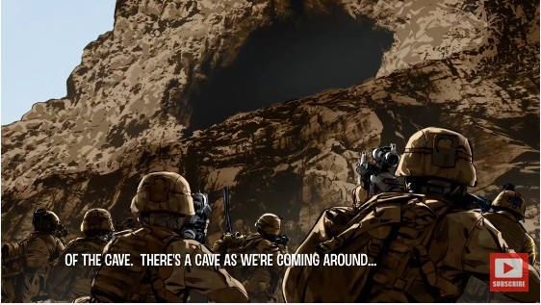
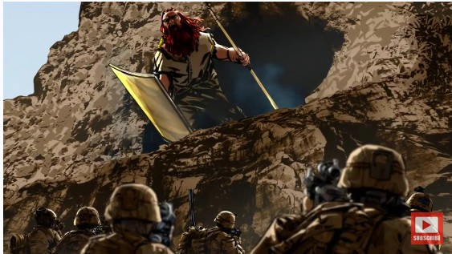
In his show, Noory asks the pilot how many men were in the transport team inside the C-130, and the pilot says “six men”. When he caught sight of the cadaver, whose face was destroyed by the bullets, the pilot noted that the giant had six fingers, a height of about 12 feet, and a net weight of about 1,200 pounds.
At this point Marzulli goes back to “Mr. K” ‘s account. He remembers that when it was all done, and the giant lied dead on the ground, they checked Dan but he was already dead. Why this had to happen? The military asked, still in shock.
Before leaving the area the “9 line”, that is, the request of evacuation and medical assistance, had been already sent, but suddenly the Task Force receives a new code and a helicopter shows up, rising vertically from the ravine below the clearing [it doesn’t arrive from the sky] and discharge some hauling nets. The orders are to secure the giant inside the nets. After that, another, larger helicopter arrives (the Chinook choppers have enough power to fly at a medium altitude, and only the largest crafts can fly over the mountains in that area.)

It was impossible to move the giant off the ground by hands, it was too big and

“had a terrible stench, worse than a skunk, like a cadaver who had remained outside for a while...”

Says “Mr. K.” When the helicopter took off with the net hooked up under, the signal that was sent to the headquarters was “a large, potentially human creature.”
How did you feel after that dramatic encounter? Anger, obviously, for my dead companion, but not only that. In their final report the soldiers are ordered to lie, to “tweak” the order of the events in accordance to what their superiors told them.
Marzulli asks “Mr. K” to describe the giant one more time: it had six digits on his hands and feet, and its nails were weird because they had some fungi-like, bulky things on them, and their edges were irregular.
The special unit is placed inside the Chinook chopper, and the two crafts go back to base for a debriefing. On that occasion the soldiers are ordered to sign a paper in which they committed to not disclosing any details about that event, on top of falsifying the final report.
The reason why “The Shooter” decided to break the silence is because he believes that the people have the right to know what is happening on our planet.

For as fantastic as this story may sound, this testimony matches with the one Quayle had presented few years back.
Marzulli asks “Mr. D”, the former “”Special Op” soldier who had heard about the Giant of Kandahar when he was in Afghanistan, whether he believes that the American people, and the people in general, had to have the right to know if there are beings other than humans living on Earth.
“Mr. D” replies without hesitation:

“My idea is that if things go exactly as the Bible says, they don’t want it. If things go against Darwin’s Evolution, it can’t be spoken out.”

“Mr. D” stresses how the story of the Giant of Kandahar was something that all military knew, and took them as something really happened. When “Mr. D” when back to the U.S. after his service in Afghanistan ended, he met other military who had served elsewhere. Yet, if I told them about the Giant of Kandahar, everyone had heard about it.

“In the beginning you think: it must be a joke, a hoax. But when things start to go down a certain way, when you keep hearing about the story, you realize that it’s not a joke. They kept on telling us to point our weapons up high: normally this means two [shots] in the body and one in the head. But they told us to point them always to the head of a man, and then a little higher. And we wondered why they wanted us to shoot above a man’s head?”
Marzulli asks him to confirm the time in which the fight with the giant allegedly happened: it was 2002. “Mr. D” was serving in Afghanistan in 2005. If one has to make up a story for some unknown reason, why creating a creature identical to the Nephilim as described in the Bible? Why going down the road that the USG avoids in order to keep the people from knowing?
“Mr. D” said that such a fake story wouldn’t make any sense. During his active service in Afghanistan he witnessed things that he has never been able to explain, such as lights in the sky during the shooting, and Orbs or tennis ball-sized spheres which flew around making strange sounds. The man had similar experiences in Iraq as well (near the Hadifah Dam area), when he was on duty in the underground prisons below the dam. He tells how the prisoners kept on screaming about a terrible feeling that haunted the place. Later “Mr. D” read the Bible and learnt that an angel had been chained in that very place (Hadifah Dam is on the river Euphrates), specifically, in the Book of Revelation 9:14-15:

“Saying to the sixth angel which had the trumpet,
<<Loose the four angels which are bound in the great river Euphrates>>.
And the four angels were loosed, which were prepared for an hour, and a day, and a month,
and a year, for to slay the third part of men.”
Rumors had it that the soldiers detained in the Hadifah Dam prison were scared to death, and all they screamed was that they could “hear them.” Even the guards drew straws to choose who had to go down there to get them. Nobody wanted to go down there.
Back to Afghanistan, “Mr. D” adds that rumors upon the existence of giants came also from the locals. They talked about cannibal monsters dwelling inside caves. So the soldiers compared those stories to their American “Bigfoot.”

So three different witnesses, who don’t know one another (Quayle’s witness and Marzulli’s “Mr. K” and “Mr. D”), reported the same event: the Giant of Kandahar was a true event. “Mr. D” had no idea that “The Shooter” (aka “Mr. K”) would have been interviewed. The most interesting thing about him is the type of training he was given in case of a fight inside a cave. The background for that training was that the Afghani rebels hid in caves, and that, if a shootout occurred in there, the U.S. military had to point their weapon above the head of an adult male (after firing the first bullet at head level.)
Who were (or are) the Nephilim?

RELATED ARTICLES
  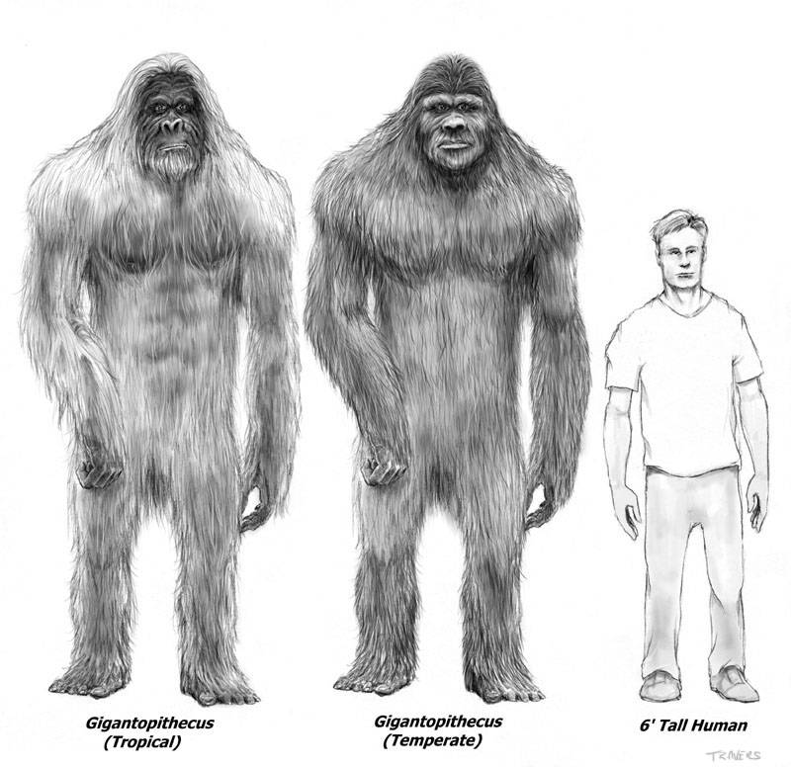
  THE BIGFOOT ENIGMA
  (X-ZONE / X-PHENOMENA)
  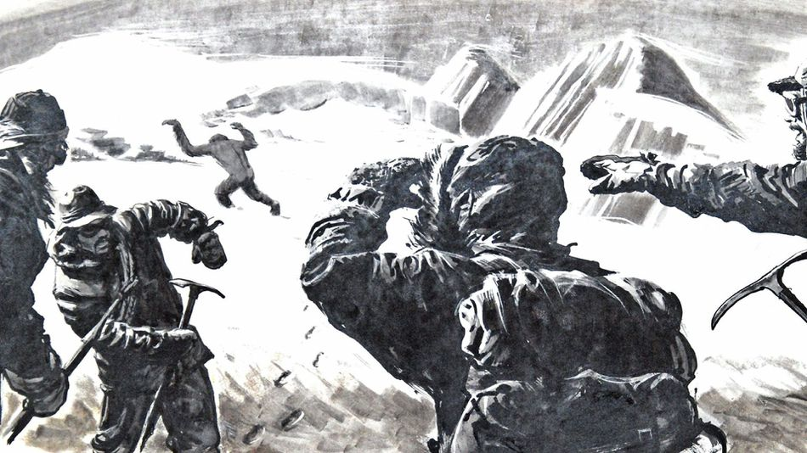
  Sasquatch - A Walk-In?
  (X-ZONE / X-PHENOMENA)

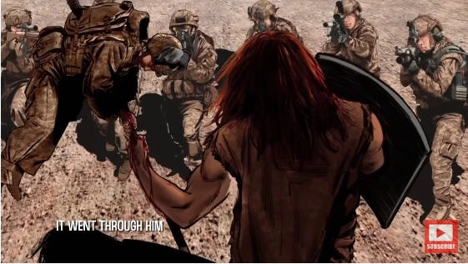
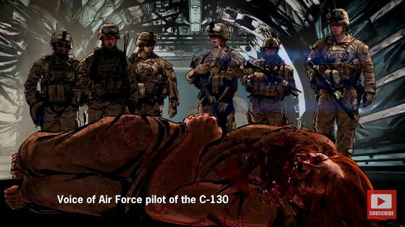
THE NEPHILIM AND THE HISTORICAL EVIDENCE
Llandudno (Northern Wales) is a coastal village with a very old copper mine. The area is located at 220 meters above the Irish Sea level, and is known as the place for the Great Orme Copper Mine. More than 2,500 hammers have been found inside this mine, all dating back to the Bronze Age (about 3,500 years ago.) It is believed that the tunnels inside the mine are several kilometers long, although only six have been explored so far. It is known with certainty that there exist nine subterranean levels, and more than 1,700 tons of copper have been extracted, an incredible feat if we think that the community of that time didn’t have any technological tools to do it, at least not the same machinery we have today.

The heaviest hammer men use today weighs about 9 Kg, but the most used are the 4.5 Kg ones. Now, let’s imagine to enlarge a 9 Kg hammer of 300%, and we would obtain a tool of 27 Kg which, to be maneuvered, should consist in a handle of close to 3 meters and a metal head as big as a cinder block. Such a tool (but also a bigger one weighing 30 Kg) was found at the Orme Mine by some archaeologists.
To put it in the right perspective, a man capable of just lift up a hammer of that size (let alone to use it) should have been 13 to 16 feet tall (or 3 times an adult male of today.)
The Bible, in the Genesis, refers to a race of giants who at that time lived on Earth. Their origin is unclear, perhaps the “Sons of the Fallen Angels and the Daughters of Man,” the Nephilim?

The Sumerian as well as Egyptians bass reliefs show remarkable evidence of enormous human beings who interact with smaller men. There are differences between the two races, for the Sumerian giant has six fingers. In order to control the two additional digits, a brain should have a different structure, either larger, or more complex, or both. All would indicate that those giants should have possessed a peculiar intelligence.
The very megalithic structures scattered all over the world, from South America (Peru) to Egypt, the Middle East (Baalbek), the British Isles (the Orkney Islands), the Pacific Ocean (Easter Island) would be clues to support the theory that a race of giants actually existed on Earth in the ancient past.

North America has a peculiar trait insofar as the prehistoric cultures are concerned, an element called UPT or Unique Physical Type: It is a series of giant humanoid skeletons with hyper-extended cranium, extra dental structure (double or triple row of teeth), directly found inside the tombs or cemeteries of Adeba-Hopewell, archaic cultures and complicated rituals of the South-East.
It is common nowadays, for the alternative history researchers, to tell how these beings were found between the XIX and XX centuries. Historians, Antiquarians, and Archaeologists have collected data all over the U.S., even though the largest concentration of these UPT remains are in the Ohio River valley and along the Mississippi river. There are many cases which bear evidence of this, from written records (still available within the municipalities of counties and cities), to internal and external studies carried out by the Smithsonian Institute.
-May, 1841 – Franklin (Kentucky), several skeletons are dug out from a farm’s field. One of them was of outstanding dimensions (at least twice the size of an adult male.)
-Jo Daviess County (Illinois), a series of burial mounds are opened after years of excavations, and a pit is found at center, that had to be dug about 70 cm below the original ground level. The bones found in the pit belonged to a race of giant stature. The skeleton had been buried in a sitting position, with its legs stretched toward the center.
-Kanawha Valley (West Virginia), the skeleton of a man at least 8 feet tall is found.

After the USG’s takeover of the American Archaeology in 1900, the academic world drew a clear political line of total denial for the existence of such anomalies. And this policy seems to work up to these days, as the episode of the Giant of Kandahar shows.
The race of giant, or Nephilim, is the first race mentioned in the Book of Genesis. The origin of the word, “Nephilim”, is defined as “Giants” but some translate it as “Those who have fallen.”
The earliest versions of the Bible however indicate “Nephilim” as giants. The Nephilim’s nature is further complicated by the ambiguous definition found in the Book of Genesis (6:4). There are indeed two different interpretations upon the origin of this race:
1) The Nephilim would be Seth’s offspring. The 4Q417 Fragment from the Qumran Scrolls contains the most ancient known mention of the “children of Seth”, claiming that God condemned them for their rebellion. Other early references about Seth’s offspring which rebelled against God and mated with the “Daughters of Cain” are in the writings of Rabbi Shimon bar Yochai, Augustine of Hippo, Julius Africanus, and in the letters attributed to Saint Clement. Even the modern Amharic’s Orthodox Bible presents the same interpretation.
2) The Nephilim would be the Angels’ offspring. A good number of ancient documents refer to the Nephilim as to the “Sons of Heaven” or angels. The Scrolls of the Dead Sea, the Book of Enoch, the Ge’ez Manuscripts, and the modern version of the Old Testament pseudepigrapha, to name a few.
Some Christian Apologetics such as Tertullian and Lactantius were of the same opinion about the Nephilim. They were convinced that they were angelic beings who mated with humans. The Genesis describes the sons of God (males, of divine nature) having intercourse with the daughters of Men (females, of human nature.) From this it seems evident that the sons of God were seen as supernatural beings.
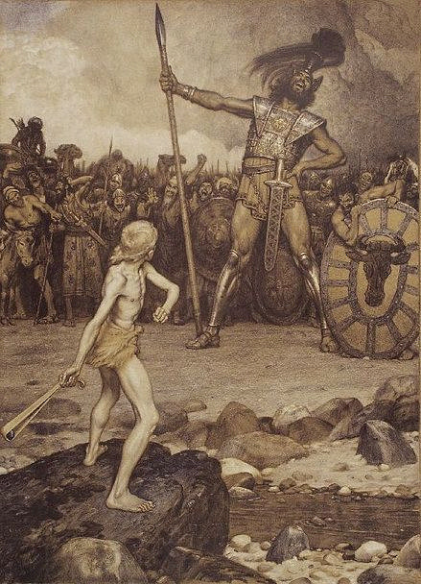

https://www.thexplan.net/article/378/The-Giant-of-Kandahar-And-The-Lost-Race-Of-The-Nephilim/it

